Summerside PEI, Canada
May 2022

…Hope and a Future (Jer. 29:11)
Although our sponsorship program in northern Mozambique includes several children still in primary school, our primary focus is on those in secondary school, university, and in vocational programs. And we are increasingly focusing our resources on preparing the most promising among them to walk into the fulness of God’s plan and purpose for their young lives.
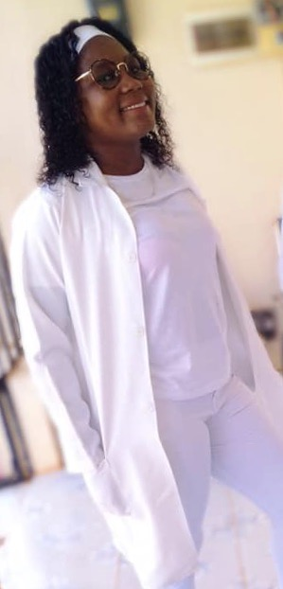
Julia (left)—along with Telma—is halfway through the lengthy university program to become a medical doctor. And Fernanda is in the same program, one year behind them. The total number of qualified medical doctors in a country of over 25 million is still only around a thousand! And most of those are men. These bright young women of God are pioneers for the future of their nation.
We are also supporting a number of youth preparing for other medical vocations. Emilia will be graduating as a nurse in a couple of months and Izak will be graduating as a medical technician at the same time. Juliana is in the same nursing program and will graduate in 2023.

Additionally, we have just registered two new students in the nursing program, who will graduate at the end of 2024. And we have at least four others who will begin their programs in February 2023. These students are all being supported through the Higher Education Fund of Summerside Community Church and/or sponsorships through Developing World Partnerships.

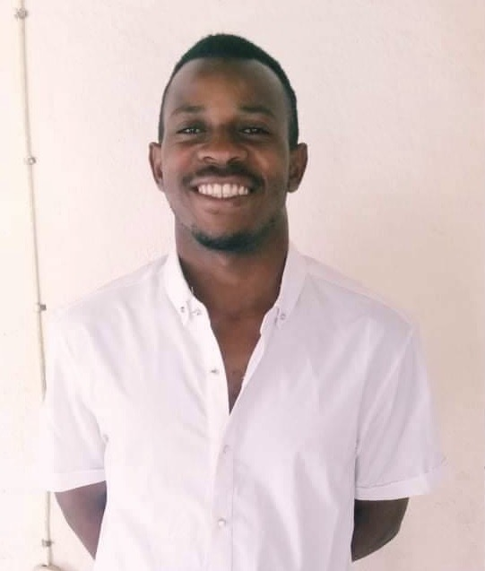
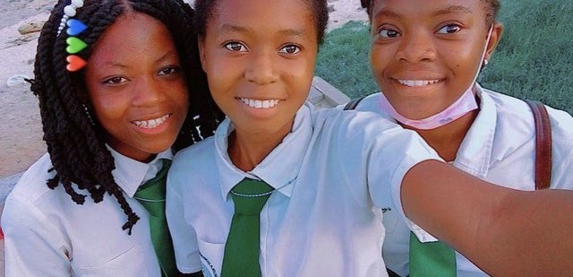
Our first university graduate was Adelino, who completed his degree from the Catholic University of Mozambique last December. Adelino has worked with Iris for several years while studying and, upon completion of his degree, has been tasked with overseeing the development of older youth within Iris Ministries.
Ancha, Aua and Bendita are three of our brightest and most committed young Mozambicans. They are currently taking extra English programs to supplement their secondary school program and will begin their medical training in February 2023. Ancha will pursue general nursing; Aua will specialize in infant and pediatric nursing; and Bendita will become a medical technician.
We currently have three young men nearing graduation from university programs in the city of Nampula, five hours’ drive south of Pemba. All three grew up in our Mieze children’s centre and then moved on to our Noviane centre for secondary school. Baptista is completing his degree in mechanical engineering; while Ferão and Nando (right) are completing education degrees to become secondary school teachers of English.
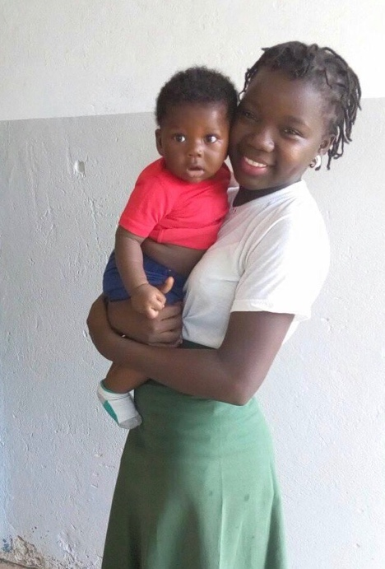
This year, we have supported two of our long-time-sponsored young women to enroll in a 15-month program to become primary school teachers. Ana began her program at the education college in Pemba and Gracinda began her program in the sister institute in the town of Montepuez, south of Pemba. Both will complete their programs in 2023. Gracinda is shown at right with her year-old son, Alexandre. Gracinda lived in our Mieze children’s centre from the age of 2 and then moved to Noviane for secondary school.
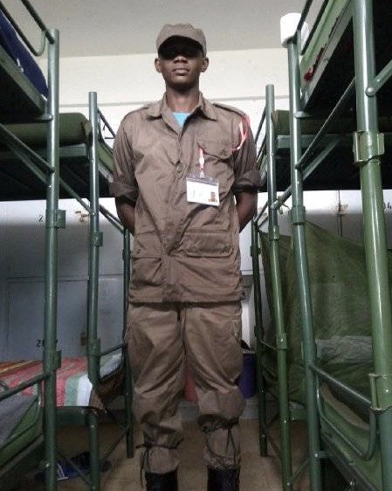
A popular vocational option for young Mozambican men and women is training for the police services…because of a guaranteed job after graduation, either in the national police force or as an Immigration police officer. We are supporting six of our sponsored youth who have completed the qualifying requirements to pursue this program in 2022. Three are currently at the training centre in Matalane (near the capital city of Maputo) and three others are waiting to begin when space is available in the program.
Pictured at left is Isac, who lived for several years at the Noviane children’s centre. He completed Grade 12 at the Iris Christian secondary school in 2021.
Our programs of sponsorship and educational support are currently assisting about 50 children, youth, and their families. All are committed young Christians walking with the Lord…and many of their extended family and friends have also given their lives to the Lord!
Sponsorships
Although we certainly welcome undesignated gifts—and even regular or occasional gifts toward my personal support—our ministry to our children and families is primarily based on your sponsorship support. Sponsors are paired with a child or children; and we will seek to double up the sponsorship of our older youth as more sponsors become available in order to increase the amount of monthly funding they receive.
Sponsorship support helps provide the basics of proper food and clothing and contributes to the costs of schooling. We also monitor the circumstances of our sponsored children to try to ensure their continued well-being. And we have high expectations for our sponsored children’s spiritual growth and for that of their families.

Contact Information: Sponsorships & Donations
Please feel free to email me if you want more information or are interested in becoming a sponsor: harvestinafrica@hotmail.com
All donations toward this work should be payable to Developing World Partnerships. They can be made via e-transfer using this email address: dwpdonor@gmail.com
or by cheques mailed to: DWP
82 St Clair Street
Summerside, PE
C1N 0L2
Automatic recurring donations for general purposes or for child sponsorship can be set up via Electronic Funds Transfer (EFT). Please contact me at my email above for further information.
Thank you for your prayers and support.
Blessings,
Don
(Dr. Don Kantel)

